High-Tech Smart Homes: Unlocking the Doors of Possibility

[Services, Apps & Software](https://www.achrnews.com/topics/2716-services-apps-software)[Apps & Software](https://www.achrnews.com/topics/2719-apps-software)

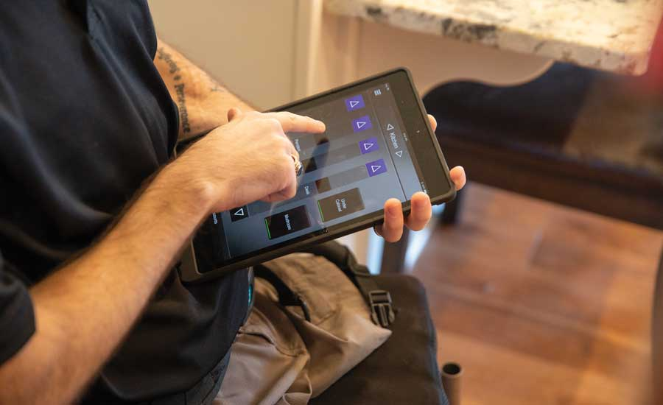

READY TO RUN: Each custom smart home built by the Gary Sinise Foundation’s R.I.S.E. program is operated via an iPad.

More than a million American heroes have returned home from Iraq and Afghanistan bearing the mental and physical wounds of war.

“Home is where we take comfort from the world,” wrote the Gary Sinise Foundation (GSF), founded by actor Gary Sinise, known for his portrayal of Lt. Dan Taylor in the film “Forrest Gump.” “For our severely wounded heroes, however, life at home can be a constant battle. Without features designed for their unique needs, small chores can become insurmountable challenges.”

Living in total reliance on caregivers for even the most mundane and sometimes very personal tasks is a reality for many of the most severely wounded — whether it’s turning on the a/c, making dinner, or getting in and out of the bathtub. That’s a need that GSF aims to support via the R.I.S.E. program, which provides custom homes for veterans, complete with smart home technology that helps them lead normal, everyday lives despite their injuries.

R.I.S.E. stands for Restoring Independence, Supporting Empowerment.

“Our specially adapted smart homes provide a safe haven for these heroes to reclaim their independence,” the foundation stated. “Built from the ground up with their individual needs in mind, these homes alleviate stress on the entire family.”

Nathan Linhardt is associate director of operations for the R.I.S.E. program.

“One of our main goals is to ease the burden of the daily challenges that a lot of the guys we build for face,” he said. “When they signed up to protect and defend our freedom, go overseas, they understood the risk involved with that. When they come back, we just want to let them know we’ve got their back, we’re here to help them out.”

SUPPORTING INDEPENDENCE

Scott Schaeperkoetter is the owner of Signature Homes, a construction company in central Missouri. He heads up the R.I.S.E. builds, something he got involved with when he built a home for GSF back in 2012.

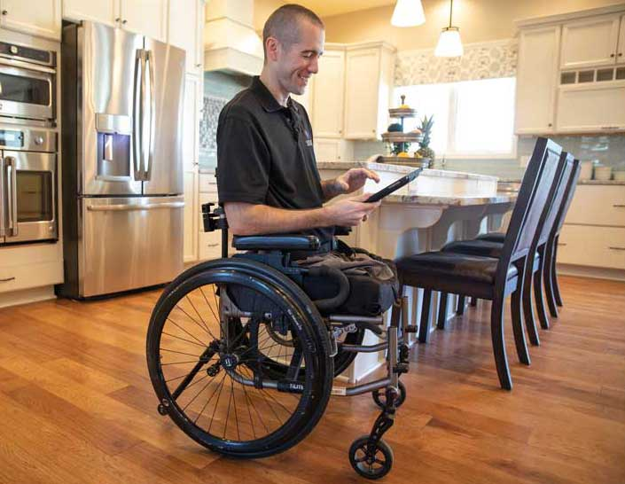COMFORT AND SECURITY: All the GSF homes are outfitted with z-wave capable thermostats and door locks, which can be controlled via the iPad, as U.S. Army Cpt. Nick Vogt is using here, or through voice-activated smart speakers.

“I worked with them managing three to four homes a year,” he said. “In November 2015, the management of R.I.S.E. was brought in-house for them, and I started working on it full time.”

The program started in 2010. To date, 51 homes have been built, with another 19 currently under construction or in the planning or design phase, for a total of 70. Schaeperkoetter said the foundation does eight to 10 houses a year.

All the houses are custom-built from the ground up.

“One of the first things we do is ask our veterans where they want to live forever,” Schaeperkoetter said. “Then we go out and purchase property.”

That’s just the first step. When installing smart home systems, contractors have the ability to customize the technology to fit individual needs.

“We do have a standard tech package we put into every home, and then depending on the specific needs or challenges the veteran faces in the home, we will adapt the technology to fit those needs,” Schaeperkoetter said. “We spend a lot of time trying to understand what those challenges are.”

Cpl. Christian Brown is a recipient of a specially adapted smart home in Munford, Tennessee. Brown enlisted in the U.S. Marine Corps in 2009 and served in Marjah, Afghanistan, then in the country’s Helmand Province in the cities of Sangin and Kajaki, where he led 163 combat missions deep in enemy territory.

On Dec. 13, 2011, while leading his squad on a foot patrol in Kajaki, Brown stepped on an improvised explosive device and sustained multiple traumas to both hands and arms, amputations of his right leg below the hip joint and left leg above the knee, internal injuries, and blast wounds to his upper left thigh.

Brown was in a dark place after his injuries, he said. During his recovery, his mom set up a fishing trip for him with the “American Hero Experience” TV show, where he met Gary Sinise in person.

“He was like, ‘By the way, I’m building you a house’ … I’m like, what?” Brown recalled the encounter.

He moved into his new specially adapted smart home in April 2016.

Really getting the user involved was what makes the R.I.S.E. smart home program a success, according to Brown.

“Every house that these guys do is custom tailored to the individual,” he said. “It all plays a significant role in helping me have the ease that you have to have to be in your house and live.”

Most of the technology is controlled via iPhone or the iPad that the recipients are presented with when they get the house.

“It’s just time to get back to being my own person ... It’s really exciting because I know I can live on my own and I can take care of myself, even in a wheelchair,” Brown said. “Everything in this house is completely equipped to allow me to live just like a normal person and have my individuality, without somebody else having to be here.”

CUSTOM MADE

One of the biggest challenges facing amputees is regulating their body temperature.

“In their current homes, before they get into the home we provide, some of our guys are always warm, some are always cold,” Linhardt said. “They want it a certain temperature. If they’re always hot, they want their air cranked down, and the rest of the family has to basically endure that.”

Plus, keeping (for example) the air at 60° to 62°F all summer long gets expensive.

R.I.S.E. addresses that issue with zoning. So if there’s an area where the individual spends a lot of time — the master bedroom, for example — it can be kept at the temperature they need, and family members in the rest of the house can be comfortable as well.

For people like one recent recipient, a double amputee, home temperature goes beyond comfort to physical and mental well-being.

“He has to have his home a certain temperature, otherwise it really messes with his day,” Schaeperkoetter said. “With PTSD or traumatic brain injury, something as simple as the temperature in-home can set them off.”

To help maintain the proper temperature and allow for easy adjustment, all the GSF homes are outfitted with z-wave capable thermostats.

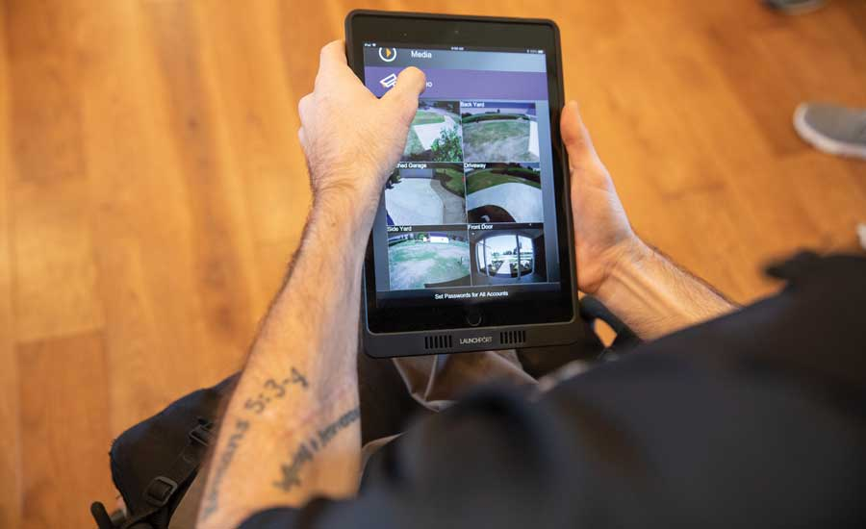FEEL SAFE: Vogt uses his iPad to view security camera footage.

“What we do is tie the thermostat into home automation systems so anytime, they can go in there and program it, or turn it up or down based on their comfort level,” Schaeperkoetter said. “If they’re going to be home in two hours, they can get on [their smartphone or iPad] and set the thermostat at the right temperature. Being able to adjust the temperature from wherever they’re at — that’s huge for them.”

“A few guys, they would always dread coming home when they had a manual thermostat,” Linhardt added. “In summer, it would be hot, and they would have to wait till it cooled down to go in. Now they can hop on their phone, can set the temperature to whatever they want it to be [in advance]. Not only is it more comfortable, but it helps the efficiency of the home as well.”

Other smart home systems that help users regain independence include lighting, fans, and blinds: things that require manual operation. For example, R.I.S.E. homes always incorporate some type of automatic blinds.

“Some of the guys who are severely burned have a light sensitivity, so being able to control the amount of light that comes through the window is key for them — in the master bedroom, master bathroom — so they don’t have to get up out of a wheelchair,” Schaeperkoetter said.

“Instead of having to exert all my energy to do the smallest tasks, I’ve got technology to help me,” Brown said. “I have touch faucets where, if I have my hands full, I can take my elbow and touch the faucet, and it comes on by itself. My blinds go up and down by remote, so I don’t have to individually let my blinds down if I’m sitting on the couch and I’ve got a glare on the TV: I don’t have to get in my chair, go over to the blinds, back in my chair, back on the couch.”

It also helps give veterans peace of mind.

“A lot of times, security is very important to these guys,” Schaeperkoetter said.

So R.I.S.E. homes incorporate as many z-wave door locks as possible and a complete alarm system with security cameras.

“We had one of our guys who would make several trips around the house at night to make sure the doors are locked.”

With his smart system, he can now get on his phone and check that the doors are locked — or, set them to lock automatically.

U.S. Marine Corps Cpl. JB Kerns is another recipient of a GSF custom home. He received the iPad and keys to his specially adapted smart home in Ararat, Virginia, in 2014; he lost both legs and his right arm during a mine sweep in Afghanistan in 2011.

“Really, what makes it smart is I can sit on the couch, have the iPad or my iPhone, turn the lights on and off, fans on and off, control heat and air, check the cameras if I want to, change the music, change the TV,” he said. “I mean, it’s crazy, what all the stuff does.”

“I think for those with physical limitations … being able to do certain things very easily, by asking Google Home, is probably the future. But then again ... it’s hard to predict what the future holds.”

— Nathan Linhardt associate director of operations R.I.S.E. program

Within the past year, Schaeperkoetter designed a home for a quadriplegic, which required a workaround for the iPad controls.

“We used some voice commands so he can open and close doors, turn lights on and off, since he’s unable to use his phone or iPad easily,” he explained.

That’s one of the things he anticipates incorporating into a lot more homes, going forward. Voice control was also central to another recent project, built for a police officer who’d been shot and paralyzed from the neck down.

“We went into this project saying if we can focus on three or four things he can accomplish himself ... that could help initially restore some of that independence,” Linhardt said.

Through voice automation, he’s able to open several doors: the back patio, the garage, the front door.

“We’ve partnered with Google to include some of [its] voice activation devices in their home,” Linhardt said. “I think for those with physical limitations … being able to do certain things very easily, by asking Google Home, is probably the future. But then again, it seems like something’s changing every day. It’s hard to predict what the future holds.”

GIVING BACK

Some of the materials and systems for the homes are donated by companies looking to help a worthy cause. R.I.S.E. has several national partners, including Nortek Security & Control and Rheem Mfg. Co.

“From Rheem’s side, it’s just a total win-win,” said Lindsey Ford, communications and events manager for Rheem and a member of the company’s Global Heart of Comfort steering committee, which oversees charitable giving. “We love when we can partner with our customers on philanthropic causes, and supporting vets just hit home.”

Rheem’s CEO, Chris Peel, and Mike Branson, general manager of Rheem’s a/c division, are both formal naval officers.

Currently, Rheem is supporting about 16 homes that are being built. One of them has a 17-SEER, two-stage system.

“Looking at these homes, we want to give the best and most efficient HVAC systems possible,” Ford said. “I think with the smart home, we’re going to see a lot more real life applications. With a community like veterans, we wanted to make sure they get smart equipment whenever possible, especially when you’re looking at mobility challenges … when they can’t move around the house, so they can get alerts on their phone, adjust the controls on their phone.

“This group has been through a lot,” she continued. “They’ve served their country so well, and we want to help in any way we can. And looking at the demographics of the consumer landscape, millennials are set to become the largest customer base in a few years. They’re looking for companies that stand behind what they believe in and are invested in a greater good. It’s such a great program … the stars aligned.”

Once local contractors learn that a R.I.S.E. home is being built in their community, many step up and donate labor and materials, Schaeperkoetter said.

“We always work with a local builder who heads up the project on a local basis; we manage that process and make sure everything goes smooth,” he said.

And the homes, which are 100 percent mortgage-free, help ensure a smoother future for some of America’s most severely wounded heroes and the families who sacrifice alongside them.

From:https://www.achrnews.com/articles/140224-high-tech-smart-homes-unlocking-the-doors-of-possibility